**S-125**



Published by the

International Hydrographic Organization

4b quai Antoine 1er

Principauté de Monaco

Tel: (377) 93.10.81.00

Fax: (377) 93.10.81.40

info@iho.int

www.iho.int

**MARINE NAVIGATIONAL SERVICES**

**Edition 0.0.1 – March 2022**

|  |
| --- |
| © Copyright International Hydrographic Organization March 2022 |
| This work is copyright. Apart from any use permitted in accordance with the [Berne Convention for the Protection of Literary and Artistic Works](http://www.wipo.int/treaties/en/ip/berne/trtdocs_wo001.html) (1886), and except in the circumstances described below, no part may be translated, reproduced by any process, adapted, communicated or commercially exploited without prior written permission from the International Hydrographic Organization Secretariat (IHO Secretariat). Copyright in some of the material in this publication may be owned by another party and permission for the translation and/or reproduction of that material must be obtained from the owner. |
| This document or partial material from this document may be translated, reproduced or distributed for general information, on no more than a cost recovery basis. Copies may not be sold or distributed for profit or gain without prior written agreement of the IHO Secretariat acting for the IHO and any other copyright holders. |
| In the event that this document or partial material from this document is reproduced, translated or distributed under the terms described above, the following statements are to be included: |
| *“Material from IHO publication [reference to extract: Title, Edition] is reproduced with the permission of the International Hydrographic Organization Secretariat (IHO Secretariat) (Permission No ……./…) acting for the International Hydrographic Organization (IHO), which does not accept responsibility for the correctness of the material as reproduced: in case of doubt, the IHO’s authentic text shall prevail. The incorporation of material sourced from IHO shall not be construed as constituting an endorsement by IHO of this product.”* |
| *“This [document/publication] is a translation of IHO [document/publication] [name]. The IHO has not checked this translation and therefore takes no responsibility for its accuracy. In case of doubt the source version of [name] in [language] should be consulted.”*  The IHO Logo or other identifiers shall not be used in any derived product without prior written permission from the IHO Secretariat. |

**Revision History**

Changes to this Product Specification are coordinated by the IHO Nautical Information Provision Working Group (NIPWG). New editions will be made available via the IHO web site. Maintenance of the Product Specification shall conform to IHO Technical Resolution 2/2007 (revised 2010).

|  |  |  |  |
| --- | --- | --- | --- |
| **Version Number** | **Date** | **Author** | **Purpose** |
| 0.0.1 | 2022-03-07 | IALA ARM S-201 TG | First Draft |
|  |  |  |  |
|  |  |  |  |
|  |  |  |  |
|  |  |  |  |
|  |  |  |  |
|  |  |  |  |
|  |  |  |  |
|  |  |  |  |
|  |  |  |  |
|  |  |  |  |
|  |  |  |  |

**TABLE OF CONTENTS**

1 Overview 6

1.1 Introduction 6

2 Reference 6

2.1 Informative 6

2.2 Normative 6

3 Terms, Definitions and Abbreviations 7

3.1 Terms and Definitions 7

3.2 Abbreviations 9

3.3 Use of Language 9

3.4 UML Notations 9

4 Specification Description 10

4.1 Informal Description of Data Product 10

4.2 Data product specification metadata 10

4.3 Product Specification Maintenance 11

4.3.1 Introduction 11

4.3.2 New Edition 11

4.3.3 Revisions 11

4.3.4 Clarification 11

4.3.5 Version Numbers 11

4.4 Specification Scope 12

5 Data product identification 12

6 Data Content and Structure 12

6.1 Introduction 12

6.2 Application Schema 14

7 Feature Catalogue 17

7.1 Introduction 17

7.2 Feature Types 18

7.2.1 Geographic 18

7.2.2 Meta 18

7.2.3 Feature Relationship 18

7.2.4 Information Types 18

7.2.5 Attributes 18

7.2.5.1 Simple Attributes 18

7.2.5.2 Complex Attributes 19

7.3 Units of Measure 19

7.4 Geometric Representation 19

8 Coordinate Reference System (CRS) 20

8.1 Introduction 20

8.2 Horizontal reference system 21

8.3 Projection 21

8.4 Vertical coordinate reference system 21

8.5 Temporal reference system 21

8.6 Coverage of nautical products data and scale 21

9 Data Quality 22

10 Data Capture and Classification 22

10.1 Data Encoding and Product Delivery 23

10.1.1 Data Encoding 23

10.1.2 Types of Datasets 23

10.1.3 Content of Update Datasets 23

10.2 Encoding of Latitude and Longitude 24

10.3 Numeric Attribute Encoding 24

10.4 Text Attribute Values 24

10.5 Mandatory Attribute Values 24

10.6 Unknown Attribute Values 24

10.7 Structure of dataset files 25

10.8 Object identifiers 25

10.9 Data coverage 25

10.10 Data overlap 25

10.11 Data extent 25

11 Data Delivery 25

11.1 Data Product Delivery Information 25

11.1.1 Dataset loading 26

11.1.2 New editions 26

11.2 Dataset size 26

11.3 Exchange Set 26

11.4 Support Files 27

11.5 Support File Naming Convention 28

11.6 Dataset Naming Convention 28

11.7 Update dataset naming convention 29

11.8 Catalogue File Naming Convention 29

12 Dataset Maintenance 29

12.1 Introduction 29

12.2 Production process for base and update datasets 29

12.3 Dataset updates and cancellation 29

12.4 Support file updates 30

12.5 Feature and portrayal catalogues 30

12.6 Feature history, versions, and change tracking 30

12.7 Dataset encryption 30

13 Portrayal 30

14 Metadata 30

14.1 Introduction 30

14.2 Dataset Metadata 33

14.2.1 Metadata for new datasets and new editions 33

14.2.2 Update and Cancellation Dataset Metadata 34

14.3 Support file Metadata 36

14.4 Exchange set catalogue and metadata 37

14.5 Metadata about feature and other catalogues 38

# Overview

## Introduction

This document has been produced by the IALA ARM Committee and the IHO Nautical Information Provision Working Group (NIPWG) in response to a requirement to produce a marine navigational service data that can be used as a Nautical Publication Information Overlay (NPIO) within an Electronic Chart Display and Information Systems (ECDIS). It is based on the IHO S-100 framework specification and the ISO 19100 series of standards. It is a vector product specification that is primarily intended for encoding the AtoNs. Marine National Services (MNS) datasets describe the list of AtoNs and status information like temporary changes, proposed changes, advance notice of changes and discrepancy. S-125 datasets would be a derivative of full Aton information as the public facing information for use in ECDIS/ECS. In other words, S-125 MNS datasets would be the digital equivalent of the extended list of lights in order to meet IMO SOLAS V requirements of having list of lights on board and serve as a continually updated list of AtoN, including virtual AtoNs.

# Reference

## Informative

The following normative documents contain provisions that, through reference in this text, constitute provisions of this document.

IHO S-100 IHO Universal Hydrographic Data Model Edition 4.0.0 (December 2018).

ISO 8601. 2004. Data elements and interchange formates - Information interchange - Representation of dates and times. 2004.

ISO 19101-2:2008 Geographic Information - Rules for Application Schema

ISO/TS 19103:2005 Geographic Information - Conceptual schema language

ISO 19106:2004 Geographic Information - Profiles

ISO 19107:2003 Geographic Information – Spatial schema

ISO 19109:2005 Geographic Information - Rules for Application Schema

ISO 19111:2003 Geographic information - Spatial referencing by coordinates

ISO 19115-1:2014, Geographic information – Metadata. Amended by Amendment 1, 2018

ISO 19115-2:2009 Geographic information - Metadata: Extensions for imagery and gridded data

ISO 19123:2005 Geographic information - Schema for coverage geometry and functions

ISO 19129:2009 Geographic information - Imagery gridded and coverage data framework

ISO 19131:2007 Geographic information - Data product specifications

ISO 19136:2007 Geographic Information – Geography Markup Language

ISO 19136-2:2015 Geographic Information – Geography Markup Language

ISO/TS 19139 Geographic Information – Metadata – XML schema implementation

## Normative

The following informative documents provide additional information, including background information, but are not required to develop applications for data conforming to this specification.

ISO/IEC 19757-3 Information technology – Document Schema Definition Languages (DSDL) – Part 3 Rule-based validation – Schematron.

ISO 19115:2006 ISO 19115:2003 Geographic Information – Metadata. As amended by Amendment 1 (2006).

IHO S-101 IHO Electronic Navigational Chart Product Specification (2021)

# Terms, Definitions and Abbreviations

## Terms and Definitions

The S-100 framework is based on the ISO 19100 series of geographic standards. The terms and definitions provided here are used to standardize the nomenclature found within that framework, whenever possible. They are taken from the references cited in clause 2.1. Modifications have been made when necessary.

**application**

manipulation and processing of data in support of user requirements (ISO 19101)

**application schema**

**conceptual schema** for data required by one or more **applications** (ISO 19101)

**conceptual model**

modelthat defines concepts of a **universe of discourse** (ISO 19101)

**conceptual schema**

formal description of a **conceptual model** (ISO 19101)

**coverage**

**feature** that acts as a function to return values from its range for any direct position within its spatial, temporal or spatiotemporal **domain** (ISO 19123)

*EXAMPLE Raster image, polygon overlay, digital elevation matrix.*

**data product**

**dataset** or **dataset series** that conforms to a **data product specification**

**data product specification**

detailed description of a **dataset** or **dataset series** together with additional information that will enable it to be created, supplied to, and used by another party

*NOTE: A data product specification provides a description of the universe of discourse and a specification for mapping the universe of discourse to a dataset. It may be used for production, sales, end-use, or other purpose.*

**dataset**

identifiable collection of data (ISO 19115)

*NOTE: A dataset may be a smaller grouping of data which, though limited by some constraint such as spatial extent or feature type, is located physically within a larger dataset. Theoretically, a dataset may be as small as a single feature or feature attribute contained within a larger dataset. A hardcopy map or chart may be considered a dataset.*

**dataset series**

collection of **datasets** sharing common characteristics (ISO 19115)

**domain**

well-defined set (ISO/TS 19103)

*NOTE: Well-defined means that the definition is both necessary and sufficient, as everything that satisfies the definition is in the set and everything that does not satisfy the definition is necessarily outside the set.*

**feature**

abstraction of real world phenomena (ISO 19101)

*NOTE: A feature can occur as a type or an instance. Feature type or feature instance will be used when only one is meant.*

**feature association**

relationship that links instances of one **feature** type with instances of the same or a different **feature** type (ISO19110)

**feature attribute**

characteristic of a **feature** (ISO 19101-1:2014, 4.1.12)

*E.g.1: A feature attribute named “color” can have an attribute value “green” which belongs to the data type “text”.*

*E.g.2: A feature attribute named length can have an attribute value “82,4” which belongs to the data type “real”.*

*Note 1: A feature attribute has a type name, a data type and a value domain associated to it. A feature attribute for a feature instance also has an attribute value taken from the value domain.*

*Note 2: In a feature catalogue a feature attribute can include a value domain but does not specify attribute values for feature instance.*

*Note 3: In UML, attribute associations and operations are representation types and are not fundamental to the type of a characteristic nor to the type of feature. All three are equally capable of representing the same characteristics of a feature. Every implementation of a characteristic is allowed to use the representation type that is most appropriate and can use several different representations for a single characteristic if required.*

*Feature associations and feature operations therefore are different types of feature attribute, the distinction between them being based on storage and access mechanism rather than semantics.*

**geographic data**

data with implicit or explicit reference to a location relative to the Earth (ISO 19109)

*NOTE: Geographic information is also used as a term for information concerning phenomena implicitly or explicitly associated with a location relative to the Earth.*

**Metadata**

information about a resource” (ISO 19115 – 1: 2014, 4.10).

**model**

abstraction of some aspects of reality (ISO 19109)

**portrayal**

presentation of information to humans (ISO 19117)

*Note: Within the scope of this International Standard Portrayal is restricted to the portrayal of geographic information” (ISO 19117:2012; 4.20).*

**quality**

totality of characteristics of a product that bear on its ability to satisfy stated and implied needs (ISO 19101)

**universe of discourse**

view of the real or hypothetical world that includes everything of interest (ISO 19101)

## Abbreviations

This product specification adopts the following convention for symbols and abbreviated terms:

ASCII American Standard Code for Information Interchange  
ECDIS Electronic Chart Display and Information Systems  
ENC Electronic Navigational Chart  
GML Geography Markup Language  
IHO International Hydrographic Organization  
IOC International Oceanographic Commission  
ISO International Organization for Standardization  
NIPWG Nautical Information Provision Working Group  
NPIO Nautical Publication Information Overlay  
UML Unified Modeling Language  
URI Uniform Resource Identifier  
URL Uniform Resource Locator  
WMS Web Map Service  
WFS Web Feature Service  
www World Wide Web  
WGS World Geodetic System  
XML Extensible Markup Language  
XSLT eXtensible Stylesheet Language Transformations

## Use of Language

Within this document, including appendices and annexes:

* “Must” indicates a mandatory requirement.
* “Should” indicates an optional requirement, that is the recommended process to be followed, but is not mandatory.

“May” means “allowed to” or “could possibly”, and is not mandatory.

* UML Notations

## UML Notations

In this document, conceptual schemas are presented in the Unified Modeling Language (UML). Several model elements used in this schema are defined in ISO standards or in IHO S-100 documents. In order to ensure that class names in the model are unique ISO TC/211 has adopted a convention of establishing a prefix to the names of classes that define the TC/211 defined UML package in which the UML class is defined. The IHO standards and this product specification make use of classes derived directly from the ISO standards, this convention is also followed in this document. In the IHO standards class names are identified by the name of the standard, such as "S100" as the prefix optionally followed by the bi-alpha prefix derived from ISO standard. For the classes defined in this product specification the prefix is "S-125". In order to avoid having multiple classes representing the same root classes, the ISO classes and S-100 classes have been used where possible; however, a new represented class is required if there is a need to alter a class or relationship to prevent a reverse coupling between the model elements introduced in this document and those defined in S-100 or the ISO model.

# \Specification Description

## Informal Description of Data Product

This clause contains general information about the data product.

**Title:** Marine Navigational Services

**Abstract:** Marine National Services (MNS) datasets describe the list of AtoNs and status information like temporary changes, proposed changes, advance notice of changes and discrepancy. S-125 datasets would be a derivative of full Aton information as the public facing information for use in ECDIS/ECS. In other words, S-125 MNS would be the digital equivalent of the extended list of lights in order to meet IMO SOLAS V requirements of having list of lights on board and serve as a continually updated list of AtoN, including virtual AtoNs.

**Content:** Datasets conforming to this specification will contain list of AtoNs and status information like temporary changes, proposed changes, advance notice of changes and discrepancy.

**Spatial Extent:** Global coverage of maritime areas.

**Specific Purpose:** Describing list and status of AtoNs and to allow the producer to exchange AtoN datasets with interested stakeholders.

## Data product specification metadata

This information uniquely identifies this Product Specification and provides information about its creation and maintenance. For further information on dataset metadata, see clause 14.

**Title:** Marine Navigational Services (MNS)

**S-100 Version**: 4.0.0

**S-125 Version**: 1.0.0

**Date**: 2022-3-7

**Language**: English

**Classification**: Unclassified

**Contact**: International Hydrographic Organization (IHO)  
 4 quai Antoine 1er,  
 B.P. 445  
 MC 98011 MONACO CEDEX  
 Telephone: +377 93 10 81 00  
 Telefax: + 377 93 10 81 40

**URL**: https://iho.int

**Identifier**: S-125

**Maintenance**: Amendments to this specification will be produced on a needs basis. For reporting issues with this specification which need correction, use the contact information.

## Product Specification Maintenance

### Introduction

Changes to S-125 will be released by the IHO as a new edition, a revision, or as a document that includes clarification. These are described below.

### New Edition

New Editions introduce significant changes. New Editions enable new concepts, such as the ability to support new functions or applications, or the introduction of new constructs or data types. New Editions are likely to have a significant impact on either existing users or future users of S-125.

### Revisions

Revisions are defined as substantive semantic changes. Typically, revisions will introduce change to correct factual errors or introduce necessary changes that have become evident as a result of practical experience or changing circumstances. A revision must not be classified as a clarification. Revisions could have an impact on either existing users or future users of this specification. All cumulative clarifications will be included with the release of approved corrections revisions.

Changes in a revision are minor and ensure backward compatibility with the previous versions within the same Edition. Newer revisions, for example, introduce new features and attributes. Within the same Edition, a dataset of one version could always be processed with a later version of the feature and portrayal catalogues. In most cases a new feature or portrayal catalogue will result in a revision of this specification.

### Clarification

Clarifications are non-substantive changes. Typically, clarifications: remove ambiguity; correct grammatical and spelling errors; amend or update cross references or; insert improved graphics in spelling, punctuation, and grammar. Clarification must not cause any substantive semantic changes.

Changes in a clarification are minor and ensure backward compatibility with the previous versions within the same Edition. Within the same Edition, a dataset of one clarification version could always be processed with a later version of the feature and portrayal catalogues, and a portrayal catalogue can always rely on earlier versions of the feature catalogues.

Changes in a clarification are minor and ensure backward compatibility with the previous versions.

### Version Numbers

The associated version control numbering to identify changes (n) to this specification must be as follows:

New Editions denoted as **n**.0.0

Revisions denoted as n.**n**.0

Clarifications denoted as n.n.**n**

## Specification Scope

This product specification describes one data product and therefore requires only one scope which is described below:

**Scope ID:** Marine Navigational Services

**Hierarchical level:** MD_ScopeCode – 005 (dataset)

**Hierarchical level name:** MNS Dataset

**Level description:** information applies to the dataset

**Extent:** EX_Extent.description: Global coverage of maritime areas

# Data product identification

This section describes how to identify data sets that conform to the specification. A dataset that conforms to this Product Specification may be identified by its discovery metadata as defined in clause 14 of this specification. The information identifying the data product may include the following items from S-100 4.0.0 clause 11-6 (adapted from ISO 19115).

|  |  |
| --- | --- |
| **title** | Marine Navigational Services |
| **abstract** | Marine Navigational Services (MNS) is a vector dataset containing list of AtoNs and status information like temporary changes, proposed changes, advance notice of changes and discrepancy. |
| **alternate title** | MNS |
| **content** | List of AtoNs and status information like temporary changes, proposed changes, advance notice of changes and discrepancy |
| **geographicDescription** | **EX_GeographicDescription:** E.g., official name of region |
| **spatialResolution** | MD_Resolution>equivalentScale.denominator (integer) or MD_Resolution>levelOfDetail (CharacterString). E.g.: “All scales” |
| **purpose** | Describing list and status of AtoNs, and to allow the producer to exchange AtoN datasets with interested stakeholders |
| **language** | EN |

# Data Content and Structure

## Introduction

An Marine Navigational Services (MNS) dataset is a feature-based product. The following sub-sections contain the product application schema expressed in UML and an associated feature catalogue. The feature catalogue provides a full description of each feature type including its attributes and attribute values in the data product.

## Application Schema

The application schema conforms to the modelling conventions of UML as constrained in S-100 Part 1, and conforms to the General Feature Model described in Part 3.

An overview of the application schema is provided in the following figure (Figure 1). The subsequent figures provide details for feature types and their relationships. The allowed values for enumeration attributes are depicted in Figures 5 - 7. In conformance to S-57 and S-101, aids to navigation are described by combinations of structure and equipment features.

* The feature type AidsToNavigation is an abstract type from which the geographic feature types for aids to navigation are ultimately derived.
* StructureObject and Equipment are abstract types which collect the attributes and relationships common to structure and equipment features respectively. The relationship that exists between them is between structure and equipment features in the combining of structure and equipment object(s) to make up an individual aid to navigation.
* GenericBeacon and GenericBuoy are abstract types which collect attributes common to multiple types of beacon and buoy features respectively.
* Links to the geographic features for individual AtoNs constituting the collection object are modelled by feature associations (the “Aggregations” and “Associations” links between Aggregation and Association classes and the common supertype for geographic AtoN features (AidsToNavigation). The type of the collection feature is indicated by the attribute categoryOfAggregation which can take the allowed values listed in the codelists of the same names.
* Structure-equipment associations are modelled by the association labelled StructureEquipment, between classes Structure and Equipment in Figure 1 below.
* Features participating in the same range system are indicated by the association labelled RangeSystem, between feature classes NavigationLine and RecommendedTrack.
* The model supports two types of AIS features, physical (real) and virtual (synthetic). The broadcasting station for virtual AIS is encoded as RadioStation, and may be associated with the virtual AIS it broadcasts by an association labelled VirtualAIS. AIS related items are shown in Figure 4.
* Only RadioStation that are AIS base stations can be included.
* The structure features are Lighthouse, Landmark, Pile, LightFloat, OffShorePlatform, LightVessel, and Silo/Tank features as well as buoys and beacons of different kinds. The detailed models of structure features are depicted in Figure 2.
* The equipment features are daymark, Fog Signal, Radar Reflector, Light, Retroreflector, Topmark, Radar Transponder Beacon, Environmental Observation Equipment, Physical AIS Aid to Navigation, and Radio Station. Daymark is allowed to act as either a structure or equipment feature in practice but this cannot at present be modelled in the application schema since S-100 discourages multiple inheritance. The detailed model of equipment features is depicted in Figure 3.

The feature classes Navigation Line and Recommended Track are neither structure nor equipment objects, and are depicted in complete detail in the overview (Figure 1). Documentation tables for the application schema are in ANNEX F.

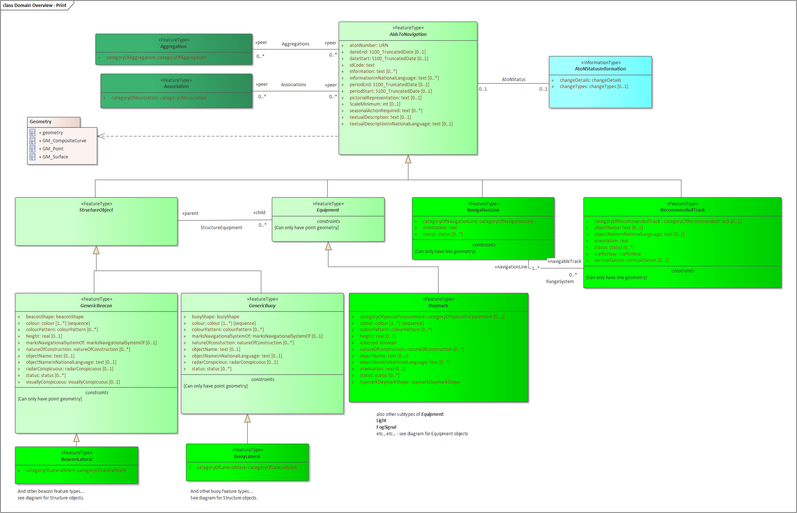

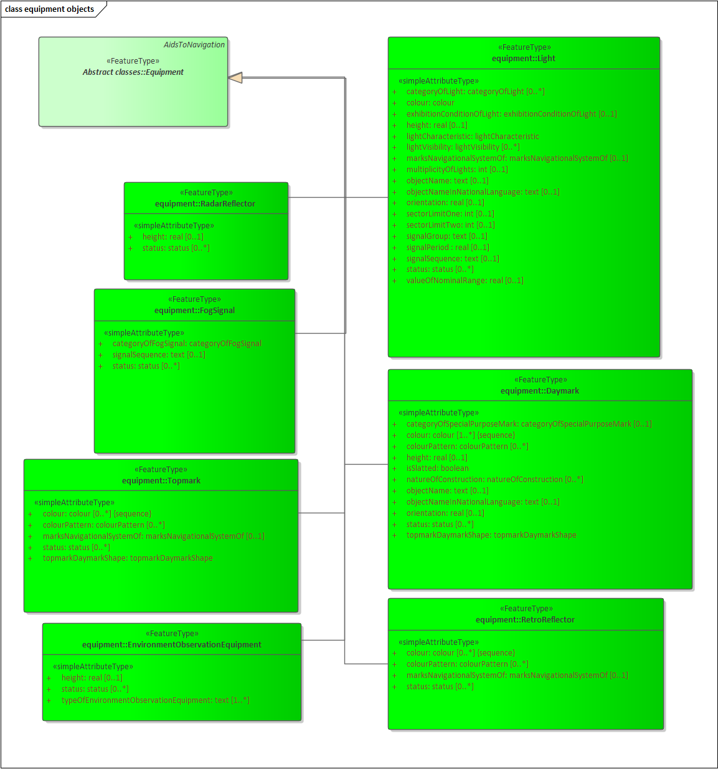

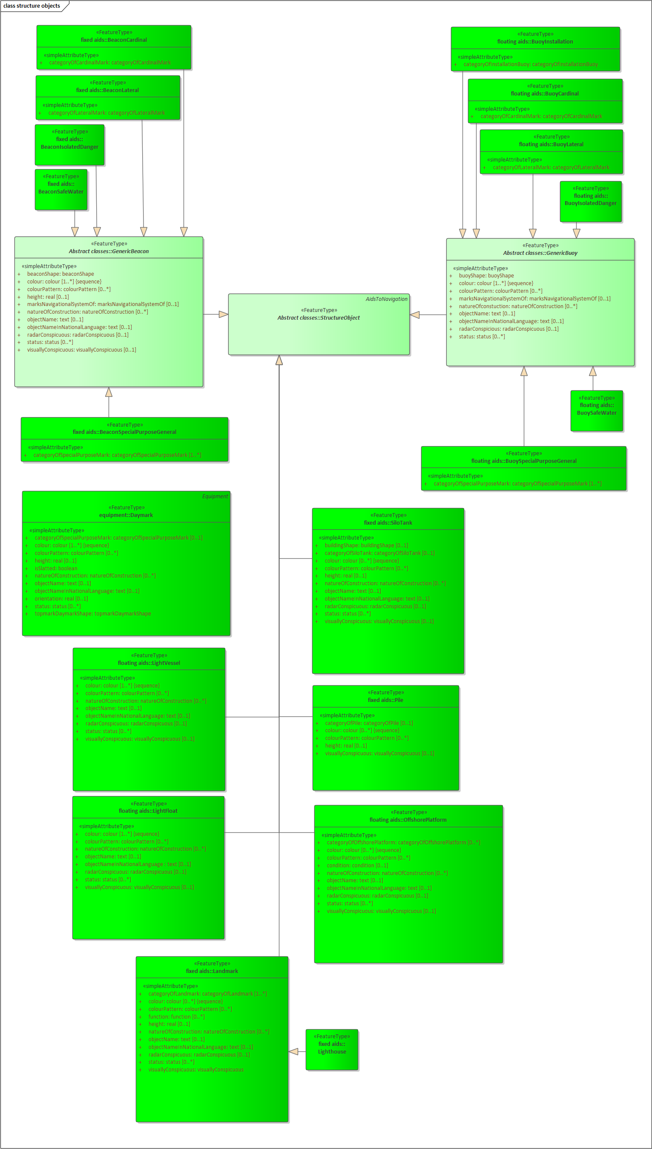

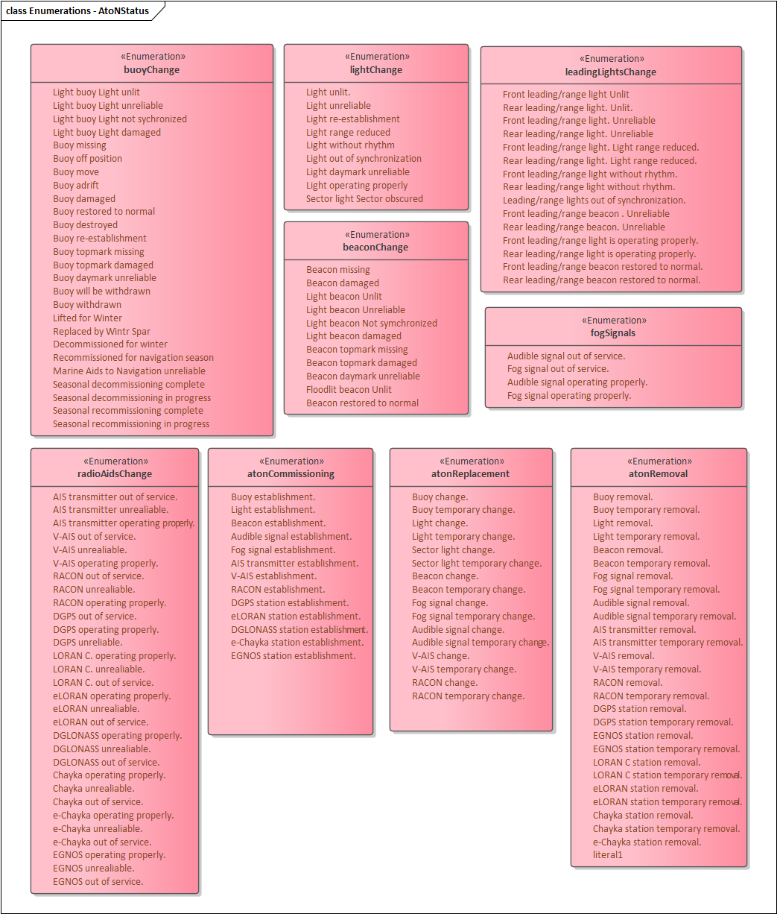

# Feature Catalogue

## Introduction

The Feature Catalogue describes the feature types, information types, attributes, attribute values, associations and roles which may be used in the product. The S-125 Feature Catalogue is available in an XML document which conforms to the S-100 XML Feature Catalogue Schema and can be downloaded from the IHO website (https://iho.int). Simple attributes used in this specification are listed in Table 7-1 below.

**Name:** Marine Navigational Services

**Scope:** Ocean, Coastal, Ports, Harbors and Inland waters

**Version Number:** 0.0.1

**Version Date:** 2022-03-07

**Producer:** International Hydrographic Organization (IHO),   
 4 quai Antoine 1er,  
 B.P. 445  
 MC 98011 MONACO CEDEX  
 Telephone: +377 93 10 81 00  
 Telefax: + 377 93 10 81 40

URL https://iho.int

**Language:** English

## Feature Types

Feature types contain descriptive attributes that characterize real-world entities. The word ‘feature’ may be used in one of two senses – feature type and feature instance. A feature type is a class and is defined in a Feature Catalogue. A feature instance is a single occurrence of the feature type and represented as an object in a dataset. A feature instance is located by a relationship to one or more spatial instances. A feature instance may exist without referencing a spatial instance.

### Geographic

Geographic (Geo) feature types carry the descriptive characteristics of a real world entity.

### Meta

Meta features contain information about other features within a data set. Information defined by meta features override the default metadata values defined by the data set descriptive records. Meta attribution on individual features overrides attribution on meta features.

### Feature Relationship

A feature relationship links instances of one feature type with instances of the same or a different feature type.

### Information Types

Information types are identifiable pieces of information in a dataset that can be shared between other features. They have attributes but have no relationship to any geometry; information types may reference other information types.

### Attributes

S-125 defines attributes as either simple or complex.

#### Simple Attributes

S-125 uses ten types of simple attributes; they are listed in the Table 7-1.

|  |  |
| --- | --- |
| **Type** | **Definition** |
| Enumeration | A fixed list of valid identifiers of named literal values. |
| Boolean | A value representing binary logic. The value can be either True or False. The default state for Boolean type attributes (i.e. where the attribute is not populated for the feature) is False. |
| Real | A signed Real (floating point) number consisting of a mantissa and an exponent. |
| Integer | A signed integer number. The representation of an integer is encapsulation and usage dependent. |
| CharacterString | An arbitrary-length sequence of characters including accents and special characters from a repertoire of one of the adopted character sets. |
| Date | A date provides values for year, month, and day according to the Gregorian Calendar. Character encoding of a date is a string which must follow the calendar date format (complete representation, basic format) for date specified by ISO 8601:1988.  EXAMPLE 19980918 (YYYY-MM-DD) |
| Time | A time is given by an hour, minute, and second. Character encoding of a time is a string that follows the local time (complete representation, basic format) format defined in ISO 8601:1988.  EXAMPLE 183059 or 183059+0100 or 183059Z |
| Date and Time | A DateTime is a combination of a date and a time type. Character encoding of a DateTime shall follow ISO 8601:1988.  EXAMPLE 19850412T101530 |
| Codelist | A type of flexible enumeration. A code list type is a list of literals which may be extended only in conformance with specified rules. |
| Truncated date | One or more components of the Date type are omitted. |

Table 7-1. Simple feature attributes.

#### Complex Attributes

Complex attributes are aggregations of other attributes that are either simple or complex. The aggregation is defined by means of attribute bindings.



Figure 7-1. textContent – a complex attribute

## Geometric Representation

Geometric representation is the digital description of the spatial component of an object as described in S-100 and ISO 19107. This product specification uses three types of geometries: GM_Point, GM_OrientableCurve, and GM_OrientableSurface.

# Coordinate Reference System (CRS)

## Introduction

The location of an object in the S-100 standard is defined by means of coordinates which relate a feature to a position. The coordinate reference system used for this product specification is World Geodetic System 1984 (WGS 84) which is defined by the European Petroleum Survey Group (EPSG) code 4326, (or similar - North American Datum 1983 / Canadian Spatial Reference System).

Spatial data is expressed as latitude (φ) and longitude (λ) geographic coordinates. Latitude values are stored as a negative number to represent a position south of the Equator. Longitude values are stored as a negative number to represent a position west of the International Prime Meridian. Coordinates are expressed as real value, degree / degree decimal format. Datasets conforming to this product specification are not projected.

**Horizontal coordinate reference system:** WGS 84

**Projection:** None

**Vertical coordinate reference system:** None

**Temporal reference system:** Gregorian calendar

**Coordinate reference system registry:** [EPSG Geodetic Parameter Registry](http://www.epsg-registry.org/)

**Date type (according to ISO 19115):** 002 - publication

## Horizontal reference system

Positional data is expressed in latitude and longitude geographic coordinates of the World Geodetic System 84 (WGS 84).

## Projection

MNS data products are un-projected.

## Vertical coordinate reference system

Marine Navigational Services data products do not provide detailed vertical information.

## Temporal reference system

Time is measured by reference to Calendar dates and Clock time in accordance with ISO 19108:2002 Temporal Schema clause 5.4.4.

## Coverage of nautical products data and scale

MNS data must be compiled in the best applicable scale. The use of the data itself is "scale independent". That means that the data can be used at any scale. S-100 allows the association of multiple spatial attributes to a single feature instance. Each of thesespatial attributes can in principle be qualified by maximum and minimum scales.

For example, it is possible, within one dataset, to have a single instance of a feature that has more than one area geometry. Each of these geometries has different scale max/min attributes. Moreover, due to cluttering in smaller scales, the scale minimum attribute may be used to turn off portrayal of some features at smaller scales.

# Data Quality

Data quality allows users and user systems to assess fitness for use of the provided data. Data quality measures and the associated evaluation are reported as metadata of a data product. This metadata improves interoperability with other data products and provides usage by user groups that the data product was not originally intended for. The secondary users can make assessments of the data product usefulness in their application based on the reported data quality measures.

For S-125 the following data quality elements have been included:

* Conformance to this Product Specification;
* Intended purpose of the data product;
* Completeness of the data product in terms of coverage;
* Logical Consistency;
* Positional Uncertainty and Accuracy;
* Thematic Accuracy;
* Temporal Quality;
* Aggregation measures;
* Elements specifically required for the data product (none currently identified for S-125);
* Validation checks or conformance checks including:
  + General tests for dataset integrity;
  + Specific tests for a specific data model.

# Data Capture and Classification

Data source: S-125 products must be based on data sources released by an appropriate MNS defining authority such as AtoN authority and Hydrographic Offices. Data source must be described in each data product.

The production process used to generate MNS products may be described in the comment attribute of the dataset metadata.

|  |  |  |  |
| --- | --- | --- | --- |
| **Item Name** | **Description** | **Multiplicity** | **Type** |
| dataSource | Identification of the kinds of data sources  usable to product datasets compliant with the  considering specification | 0..* | CharacterString |
| productionProcess | Link to a textual description of the production  process (including encoding guide)  applicable to the datasets compliant with the  considering specification | 0..* | CharacterString (URL) |

Table 10-1. Data capture information

## Data Encoding and Product Delivery

### Data Encoding

The principal encoding will be the Open Geospatial Consortium (OGC), Geography Markup Language (GML) format. GML is an XML grammar designed to express geographical features. It serves as a modeling language for geographic systems as well as an open interchange format for geographic transactions.

### Types of Datasets

A dataset is a grouping of features, attributes, geometry, and metadata which comprises a specific coverage. The following lists the types of MNS datasets which may be produced and contained within an exchange set:

|  |  |
| --- | --- |
| **Dataset** | **Explanations** |
| New dataset (base dataset): | Data for an area different (in coverage and/or extent) to existing datasets. |
| New Edition of a dataset: | A re-issue plus new information which has not been previously distributed by Updates. Each New Edition of a dataset must have the same name as the dataset that it replaces and should have the same spatial extents. The edition number in the dataset discovery metadata shall increment up by one from the previous edition. |
| Update dataset | A data replacement of the latest edition of a dataset. |
| Cancellation | Used to cancel dataset and any related update datasets. |

Table 10-2. MNS dataset types

### Content of Update Datasets

Update datasets can only contain replacements, deletions, and additions of whole feature instances or information instances. This means that when a feature or information instance is updated, the new version must contain all the attributes of the old instance, including any inline spatial attributes (i.e., inline geometry), except those attributes that are being removed.

An association to an instance of a feature or information type is treated as an attribute of the referring instance, and therefore adding or deleting an association means the original referring instance must be replaced with a new version. The instance at the other end of the association needs to be replaced if and only if it contains a reference to the first instance.

Spatial objects that are not inline (i.e., geometry that is encoded as an independent spatial object in the dataset) are treated like any other object, i.e., it needs to be updated if and only if the primitive has changed (e.g., a coordinate is updated).

Feature and information type instances are deleted without replacement by setting the fixedDateRange.dateEnd attribute of the instance to the date of deletion, which will usually be the issue date of the update.

## Encoding of Latitude and Longitude

Values of latitude and longitude must not be more accurate than 7 decimal places. Coordinates must be encoded as decimals in the format described in Clause 10.2.1.

Values should be coded as decimal numbers with 7 or fewer digits after the decimal. The normative encoding is in degrees, with an accuracy of 10-7 degrees, i.e., 7 digits after the decimal point.

The decimal point must be indicated by the “.” character.

Trailing zeroes after the decimal point (and the decimal point itself if appropriate) may be omitted at producer discretion, but the accuracy must still be as indicated (e.g., 10-7 degrees for coordinates of default accuracy).

## Numeric Attribute Encoding

Floating point and integer attribute values must not contain leading zeros. Floating point attribute values must not contain non-significant trailing zeros.

## Text Attribute Values

Character strings must be encoded using the character set defined in ISO 10646-1, in Unicode Transformation Format-8 (UTF-8).

## Mandatory Attribute Values

There are four reasons why attribute values may be considered mandatory:

* They determine whether a feature is in the display base.
* Certain features make no logical sense without specific attributes.
* Some attributes are necessary to determine which symbol is to be displayed.
* Some attributes are required for safety of navigation.

All mandatory attributes are identified in the Feature Catalogue and summarized in Annex A – Data Classification and Encoding Guide.

## Unknown Attribute Values

When a mandatory attribute code or tag is present but the attribute value is missing, it means that the producer wishes to indicate that this attribute value is unknown. Missing mandatory attributes must be “nilled”.

Optional attributes must be omitted altogether if the value is unknown or missing. They must not be “nilled.”

EXAMPLE A landmark feature has unknown category of landmark (mandatory attribute) and function (optional attribute). The feature could be coded as:

<Landmark>

<categoryOfLandmark xsi:nil="true"/>

<function>radio</function>

… other attributes…

… <status> is NOT coded …

<Landmark>

## Structure of dataset files

The order of data objects in each dataset file is described below:

Dataset Identification Information

Dataset structure information

Spatial records for by-reference geometries

Point

Curve

Composite Curve

Information objects

Feature objects (Geometry may be encoded inline or by reference.)

Meta features

Geo features

## Object identifiers

The “name” of feature records must provide a unique world-wide identifier of feature records. The “name” of the record is the combination of the subfields **agency**, **featureObjectIdentifier**, and **featureIdentificationSubdivision** elements of the **featureObjectIdentifier** element of the object.

Features, information types, collection objects, meta features, and geometries (inline or external) are all required by the schema to have a **gml:id** attribute with a value that is unique within the dataset. The **gml:id** values must be used as the reference for the object from another object in the same dataset or another dataset.

## Data coverage

All areas of a dataset must be covered by a **DataCoverage** meta feature.

An update dataset must not change the limit of a **Data Coverage** feature for the base dataset. Where the limit of a **Data Coverage** feature for a base dataset is to be changed, this must be done by issuing a new edition of the dataset.

## Data overlap

S-125 datasets can overlap other S-125 datasets.

## Data extent

Datasets must not cross the 180° meridian of longitude.

# Data Delivery

## Data Product Delivery Information

This data product specification defines GML as the primary format in which MNS data products are delivered. The delivery format is described by the following items (from ISO 19131:2005): format name, version, specification, language, and character set.

|  |  |  |
| --- | --- | --- |
| **Name** | **ISO 19131 Elements** | **Value** |
| Format name | DPS_DeliveryInformation.deliveryFormat > DPS_DeliveryFormat.formatName | GML* |
| Version | DPS_DeliveryInformation.deliveryFormat > DPS_DeliveryFormat.version | 3.2.1 |
| Specification description | DPS_DeliveryInformation.deliveryFormat > DPS_DeliveryFormat.specification | GML* |
| Language | DPS_DeliveryInformation.deliveryFormat > DPS_DeliveryFormat.language | English |
| Character set | DPS_DeliveryInformation.deliveryFormat > DPS_DeliveryFormat.characterSet > MD_CharacterSetCode | 004 – utf8 |

Table 11-1. Data product delivery format

* GML is an XML encoding for the transport and storage of geographic information, including both the geometry and the properties of geographic features, between distributed systems. The XML Schema for the GML application schema is provided in a schema document S125.xsd which imports other schema(s) defining common types. (All files are available on the S-100 distribution site https://github.com/IHO-S100WG). Feature instance shall validate against S125.xsd and conform to all other requirements specified in this data product specification including all constraints not captured in the XML Schema document.

### Dataset loading

Datasets must always be loaded in the order of base dataset first, then update datasets in the corrected sequential order. Systems are not to load updates out of order, for example if update 1-5 is present and update 1-6 is missing, update 1-7 must not be loaded.

### New editions

When a new edition of a dataset is received, the system must replace the previous edition, along with any updates, with the new edition of the dataset. Loading of subsequent updates follows the same rule as above.

## Dataset size

MNS datasets must not exceed 20MB.

## Exchange Set

Data which conforms to this product specification must be delivered by means of an exchange set. An exchange set will consist of one or more MNS datasets. An exchange set may also include one or more support files containing supplementary information encoded in separate files. These are linked to the MNS dataset features, by feature and information type attributes defined in the application schema, e.g., **fileReference**. Each exchange set will include a single (XML) catalogue file. S-125 exchange set catalogues conform to S-100 4.0.0 Figure 4a-D-2 without modification, containing discovery metadata for each MNS dataset as well as support files. S-125 exchange set structure conforms to S-100 4.0.0 Figure 4a-D-3 without modification.

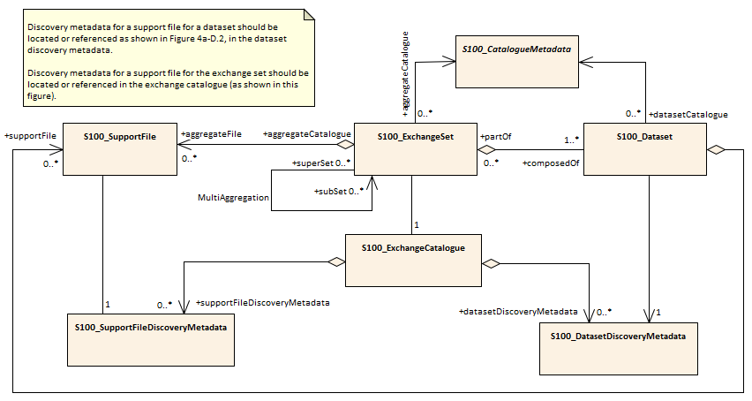

Figure 11-1. Exchange set structure

## Support Files

Support files contain ancillary textual or graphic information in separate (linked to the dataset) files. The following formats are allowed for support files:

* Plain text files must contain only general text as defined in this standard. Files must use the UTF-8 character set encoding.
* HTML and XML files must contain only text and markup as defined in the relevant W3C standards. Files must use the UTF-8 character set encoding. References in datasets to HTML and XML support files must treat them as text files (i.e., they should not be referenced using attributes intended for picture files).
* Picture files must be in the Tagged Image file Format (TIFF) [Edition 6.0].

Support files shall be used for data management and additional information to users. Portraying and using support files in ECDIS or other systems is not mandatory. Table 11.2 describes the constraints on support file formats and provides the corresponding file extensions.

|  |  |  |
| --- | --- | --- |
| **File type** | **Extension** | **Description** |
| Text | TXT |  |
| HTM | HTML files must only include inline or embedded Cascading Style Sheet (CSS) information and must not contain embedded Javascript or other dynamic content, for example DHTML, Flash etc. |
| XML | XML documents must only be included in accordance with guidance provided within the Data Classification and Encoding Guide (Annex A) and must not contain embedded Javascript or other dynamic content. |
| Picture | TIF | Baseline TIFF 6.0. |

Table 11-2. Support file formats and extensions

## Support File Naming Convention

All support files will have unique world-wide file identifiers. The file identifier of support information should not be used to describe the physical content of the file. The support file metadata that accompanies the file will inform the user of the name and purpose of the file (new, replacement, and deletion).

In this encoding the support files are named according to the specifications given below:

125CCCCXXXXXXXXXX.YYY

The main part forms an identifier where:

* The first three characters are always “125” and identify the dataset as an S-125 dataset.
* The next four characters identify the issuing agency by its alphanumeric agency code in the IHO producer code register in the IHO GI Registry (i.e., the IHO is identified as “AA”, not “1810”). Where the agency code consists of fewer than four characters, sufficient zeros must be suffixed to make the length exactly four characters (e.g., “AA00” for IHO).
* The eighth up to the seventeenth character can be used in any way by the producer to provide a unique file name for the dataset. The following characters are allowed in the dataset name. A to Z, 0 to 9, and the special character _ (underscore). The ninth through seventeenth characters are optional (i.e., at least one character must be used).
* .YYY – support file extension. The YYY portion must conform to the file format as described in Table 11.2.

## Dataset Naming Convention

All dataset files will have unique world-wide file identifiers. The file identifier of the dataset should not be used to describe the physical content of the file. The dataset file metadata that accompanies the file will inform the user of the name and purpose of the file (new, replacement, and deletion).

In this encoding the dataset files are named according to the specifications given below:

125CCCCXXXXXXXXXX.GML

The main part forms an identifier where:

* The first three characters are always “125” and identify the dataset as an S-125 dataset.
* The next four characters identify the issuing agency by its alphanumeric agency code in the IHO producer code register in the IHO GI Registry (i.e., the IHO is identified as “AA”, not “1810”). Where the agency code consists of fewer than four characters, sufficient zeros must be suffixed to make the length exactly four characters (e.g., “AA00” for IHO).
* The eighth up to the seventeenth character can be used in any way by the producer to provide a unique file name for the dataset. The following characters are allowed in the dataset name, A to Z, 0 to 9 and the special character _ (underscore). The ninth through seventeenth characters are optional (i.e., at least one character must be used).

## Update dataset naming convention

All update dataset files will have an identical name to the base dataset, aside from the separator and update number sequence.

In this encoding the update dataset files are named according to the specifications given below:

125CCCCXXXXXXXXXX_XXX.GML

The main part forms an identifier where:

* The first up to the seventeenth characters are the same as the dataset being updated and therefore conform to the rules described in clause 11.6.
* The next character must be an underscore “_”.
* The next three characters must be numerical (0-9) characters to indicate the place of the update dataset in the update sequence.

## Catalogue File Naming Convention

The exchange catalogue acts as the table of contents for the exchange set. The catalogue file of the exchange set must be named CATALOG.XML. No other file in the exchange set may be named CATALOG.XML. The content of the exchange catalogue file is described in Clause 14.

# Dataset Maintenance

## Introduction

Datasets are maintained as needed and must include mechanisms for MNS updating. Data updates will be made by new editions or updates. The maintenance and update frequency of MNS datasets should be defined by the producers (official national authority) implementing this specification.

Data Producers must use applicable sources to maintain and update data and provide a brief description of the sources that were used to produce the dataset in the appropriate metadata field.

## Production process for base and update datasets

Data Producers should follow their established production processes for maintaining and updating datasets. Data is produced against the DCEG and checked against the appropriate set of validation rules in Appendix X.

## Dataset updates and cancellation

The purpose of issue of the dataset is indicated in the “purpose” field of the dataset discovery metadata. In order to terminate a dataset, an update dataset file is created for which the edition number must be set to 0. This convention is only used to cancel a base dataset file.

Where a dataset is cancelled and its name is reused at a later date, the issue date must be greater than the issue date of the cancelled dataset.

When the dataset is cancelled, it must be removed from the system.

An exchange set may contain base dataset files and update dataset files for the same datasets. Under these circumstances the update dataset files must follow in the correct sequential order from the last update applied to the base dataset file.

## Support file updates

The purpose of issue is indicated in the “purpose” field of the support file discovery metadata. Support files carrying the “deletion” flag in metadata must be removed from the system. When a feature or information type pointing to a text, picture, or application file is deleted or updated so that it no longer references the file, the system software must check to see whether any other feature or information type references the same file, before that file is deleted.

Updates, in form of a new edition or a replacement, or deletions of a support file may require concurrent updates to feature or information type instance attributes that depend on the file, e.g., pictorialRepresentation, fileReference, and fileLocator attributes.

## Feature and portrayal catalogues

For each new version of the S-125 Product Specification a new feature and portrayal catalogue may be released. The system must be able to manage datasets and their catalogues that are created on different versions of the S-125 product specification.

## Feature history, versions, and change tracking

If applications or production systems require versioning of individual instances of feature or information types, maintenance of histories, or change tracking, the methods for versioning, history management, and change tracking and display are left to the application or production system.

## Dataset encryption

Details about dataset encryption are still to be determined, and may mirror the method described in S-101.

# Portrayal

Portrayal is not defined in this version of S-125 Marine Navigational Services Specifications. Users are free to choose the means and methodology of portrayal as they see best suited for their needs. It should be noted that future versions of S-125 may include a portrayal catalogue, and any implementer should therefore anticipate this, and make sufficient provisions in any system supporting S-125.

# Metadata

## Introduction

The MNS metadata specification conforms to the S-100 metadata specification in Part 4a, which is a profile of the ISO 19115-1 standard. These documents provide a structure for describing digital geographic data and define metadata elements, a common set of metadata terminology, definitions, and extension procedures.

The overall structure of metadata in S-125 exchange sets is the same as in S-100, and is depicted in Figure 14.1. Metadata in exchange sets consists of discovery metadata for the datasets and support files in the exchange set (classes S100_DatasetDiscoveryMetadata and S100_SupportFileDiscoveryMetadata), metadata in ISO 19115-1 format for datasets, and metadata about any feature, portrayal, or interoperability catalogues which are in the exchange set (S100_CatalogueMetadata).

The discovery metadata classes have numerous attributes which enable important information about the datasets and accompanying support files to be examined without the need to process the data, for example decrypt, decompress, load, etc. Other catalogues such as feature and portrayal catalogues can be included in the exchange set in support of the datasets.

More detailed information for the classes is depicted in Figure 14.2 and details about the metadata classes are provided in Clauses 14.2–14.5.

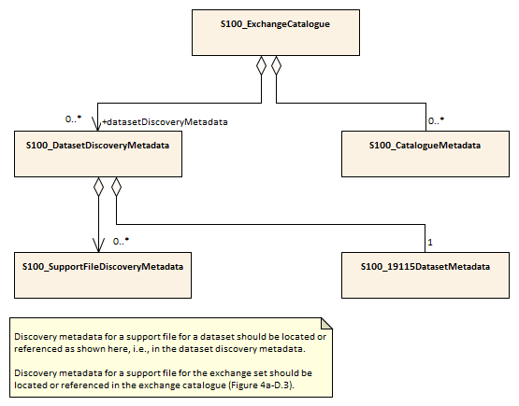

Figure 14-1. Metadata in exchange catalogue

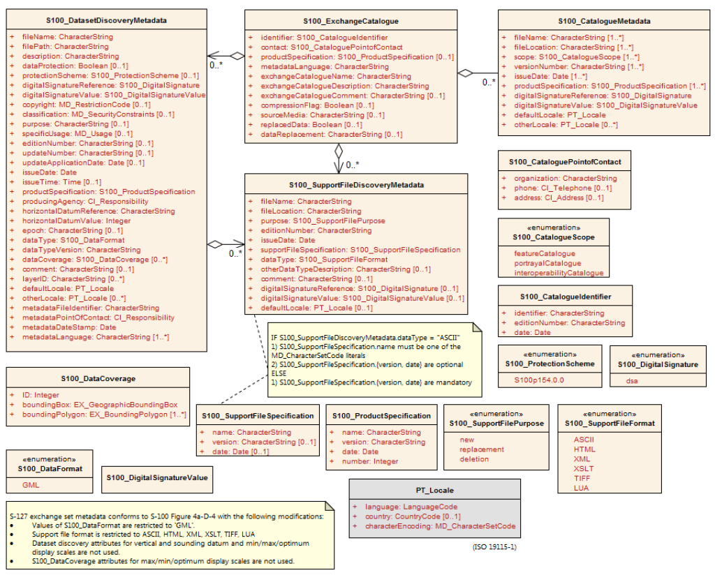

Figure 14-2. S-125 Exchange catalogue and discovery metadata

NOTE 1: Types with CI_, EX_, and MD_ prefixes are from packages defined in ISO 19115-1 and 19115-3 and adapted by S-100. Types with S100_ prefix are from packages defined in S-100.

NOTE 2: When a dataset is terminated, the purpose metadata field is set to 3 (terminated), and the editionNumber metadata field is set to 0. All inapplicable but mandatory metadata fields must be nilled.

In Figure 14-2 and the following clauses, classes show only those attributes which are used in S-125 exchange catalogues. Similarly, enumerations show only those values which are allowed in S-125 exchange catalogues.

## Dataset Metadata

Dataset metadata is intended to describe information about a dataset. It facilitates the management and exploitation of data and is an important requirement for understanding the characteristics of a dataset. Whereas dataset metadata is usually fairly comprehensive, there is also a requirement for a constrained subset of metadata elements that are usually required for discovery purposes. Discovery metadata are often used for building web catalogues, and can help users determine whether a product or service is fit for purpose and where they can be obtained.

### Metadata for new datasets and new editions

Dataset discovery metadata for new datasets and new editions of published datasets is described in Table 14.1.

|  |  |  |  |
| --- | --- | --- | --- |
| **Name** | **Multiplicity** | **Type** | **Remarks** |
| S100_DataSetDiscoveryMetadata |  | Class | The following S-100 attributes are not used: verticalDatum, soundingDatum, optimumDisplayScale, maximumDisplayScale, minimumDisplayScale. |
| fileName | 1 | CharacterString | Dataset file name (see 11.6) |
| filePath | 1 | CharacterString | Full path from the exchange set root directory |
| description | 1 | CharacterString | Short description of the area covered by dataset, e.g., area, harbour, or port name, between two named locations etc. |
| dataProtection | 0..1 | Boolean | TRUE: Encrypted  FALSE: Unencrypted |
| protectionScheme | 0..1 | S100_ProtectionScheme | See S-100 Appendix 4a-D. |
| digitalSignatureReference | 1 | S100_DigitalSignature | Specifies the algorithm used to compute digitalSignatureValue.  See S-100 Appendix 4a-D. |
| digitalSignatureValue | 1 | S100_DigitalSignatureValue | The value resulting from application of digitalSignatureReference.  Implemented as the digital signature format specified in S-100 Part 15. |
| copyright | 0..1 | MD_LegalConstraints>MD_RestrictionCode  <copyright> (ISO 19115-1) | “copyright” for copyrighted datasets, omitted otherwise |
| classification | 0..1 | Class  MD_SecurityConstraints>MD_ClassificationCode (codelist)  ISO 19115-1 | 1. unclassified  2. restricted  3. confidential  4. secret  5. top secret  6. sensitive but unclassified  7. for official use only  8. protected  9. limited distribution |
| purpose | 1 | MD_Identification>purpose (character string) | 1. New dataset 2. New edition |
| specificUsage | 1 | MD_USAGE>specificUsage  (character string)  MD_USAGE>userContactInfo  (CI_Responsibility) | brief description of the resource and/or resource series usage |
| editionNumber | 1 | CharacterString | When a dataset is initially created, the edition number “1” is assigned to it. The edition number is increased by one with each new edition. |
| issueDate | 1 | Date | Date on which the dataset was generated. |
| issueTime | 0..1 | Time | Encoded only if time of issue is significant. |
| productSpecification | 1 | S100_ProductSpecification | See Notes below this table for constraints on values. |
| producingAgency | 1 | CI_Responsibility>CI_Organisation or  CI_Responsibility>CI_Individual | Party responsible for generating the dataset.  See Part 4a Tables 4a-2 and 4a-3. |
| horizontalDatumReference | 1 | CharacterString |  |
| horizontalDatumValue | 1 | Integer | WGS84 |
| epoch | 0..1 | CharacterString | For example, G1762 for the 2013-10-16 realization of the geodetic datum for WGS84 |
| dataType | 1 | S100_DataFormat | The only value allowed is “GML”. |
| dataTypeVersion | 1 | CharacterString |  |
| dataCoverage | 1..* | S100_DataCoverage | See S-100 Appendix 4a-D. A new or new-edition S-125 dataset must have at least one coverage. |
| comment | 0..1 | CharacterString | Any additional Information |
| layerID | 1..* | CharacterString | Dataset must be used with ENC in an ECDIS.  Mandatory for S-125 new datasets and new editions. |
| defaultLocale | 1 | PT_Locale | See S-100 Appendix 4a-D. |
| otherLocale | 0..* | PT_Locale | See S-100 Appendix 4a-D. |
| metadataFileIdentifier | 1 | CharacterString | For example, identifier for ISO 19115-3 metadata file |
| metadataPointOfContact | 1 | CI_Responsibility>CI_Individual or  CI_Responsibility>CI_Organisation | See S-100 Part 4a Tables 4a-2 and 4a-3. |
| metadataDateStamp | 1 | Date | Metadata creation date, which may or may not be the dataset creation date |
| metadataLanguage | 1..* | CharacterString |  |
| -- | 0..* | Aggregation S100_SupportFileDiscoveryMetadata | One for each support file linked to this dataset and present in the exchange set. |

Table 14-1. Dataset discovery metadata

NOTES:

1. Attribute *productSpecification*: The values of sub-attributes *name* and *version* must correspond to this version of the S-12 product specification. (Clause 4.2). The value of sub-attribute *number* must be the number assigned to this version of the S-125 product specification in the GI registry.

### Update and Cancellation Dataset Metadata

Update dataset metadata (Table 14.2) is intended to describe information about an update dataset. It facilitates the management and exploitation of data and is an important requirement for understanding the characteristics of an update dataset. Whereas dataset metadata is usually fairly comprehensive, metadata for update datasets only describe the issue date and sequential relation to the base dataset.

Update dataset discovery metadata omits the dataCoverage, specificUsage and layerID metadata attributes.

|  |  |  |  |
| --- | --- | --- | --- |
| **Name** | **Multiplicity** | **Type** | **Remarks** |
| S100_DataSetDiscoveryMetadata |  | Class | The following S-100 attributes are not used for update datasets: verticalDatum, soundingDatum, optimumDisplayScale, maximumDisplayScale, minimumDisplayScale, dataCoverage, specificUsage, layerID. |
| fileName | 1 | CharacterString | Dataset file name (see 11.7) |
| filePath | 1 | CharacterString | Full path from the exchange set root directory |
| description | 1 | CharacterString | Brief description of the update. |
| dataProtection | 0..1 | Boolean | Value must be same as base dataset. |
| protectionScheme | 0..1 | S100_ProtectionScheme | Value must be same as base dataset. |
| digitalSignatureReference | 1 | S100_DigitalSignature | Specifies the algorithm used to  compute digitalSignatureValue.  See S-100 Appendix 4a-D. |
| digitalSignatureValue | 1 | S100_DigitalSignatureValue | The value resulting from application of digitalSignatureReference.  Implemented as the digital signature format specified in S-100 Part 15. |
| copyright | 0..1 | MD_LegalConstraints>MD_RestrictionCode  <copyright> (ISO 19115-1) | Value must be same as base dataset. |
| classification | 0..1 | Class  MD_SecurityConstraints>MD_ClassificationCode (codelist) | Value must be same as base dataset. |
| purpose | 1 | CharacterString | 1. Update 2. Cancellation |
| editionNumber | 1 | CharacterString | Value must be same as base dataset. |
| updateNumber | 1 | CharacterString | Update sequence number, must match file name. |
| updateApplicationDate | 1 | Date | Date of update |
| issueDate | 1 | Date | Date on which the dataset was generated. |
| issueTime | 0..1 | Time | Encoded only if time of issue is significant such as when more than one update is planned in a day. |
| productSpecification | 1 | S100_ProductSpecification | Value must be same as base dataset. |
| producingAgency | 1 | CI_Responsibility>CI_Organisation or  CI_Responsibility>CI_Individual | Party responsible for generating the dataset.  See Part 4a Tables 4a-2 and 4a-3. |
| horizontalDatumReference | 1 | CharacterString |  |
| horizontalDatumValue | 1 | Integer | WGS84 |
| epoch | 0..1 | CharacterString | Must be same as base dataset |
| dataType | 1 | CharacterString |  |
| dataTypeVersion | 1 | CharacterString |  |
| comment | 0..1 | CharacterString | Any additional Information |
| defaultLocale | 1 | PT_Locale | Must be same as base dataset.  See S-100 Appendix 4a-D. |
| otherLocale | 0..* | PT_Locale | Must be same as base dataset.  See S-100 Appendix 4a-D. |
| metadataFileIdentifier | 1 | CharacterString | For example, for ISO 19115-3 metadata file |
| metadataPointOfContact | 1 | CI_Responsibility>CI_Individual or  CI_Responsibility>CI_Organisation | See S-100 Part 4a Tables 4a-2 and 4a-3. |
| metadataDateStamp | 1 | Date | Metadata creation date, which may or may not be the dataset creation date |
| metadataLanguage | 1..* | CharacterString | Must be same as base dataset |
| -- | 0..* | Aggregation S100_SupportFileDiscoveryMetadata | One for each support file that is referenced by the update dataset and present in the exchange set. |

Table 14-2. Update dataset metadata

## Support file Metadata

Support file metadata (Table 14.3) is intended to describe information about a data resource. It facilitates the management and exploitation of data and is an important requirement for understanding the characteristics of a data resource.

|  |  |  |  |
| --- | --- | --- | --- |
| **Name** | **Multiplicity** | **Type** | **Remarks** |
| S100_SupportFileDiscoveryMetadata |  | Class |  |
| fileName | 1 | CharacterString |  |
| fileLocation | 1 | CharacterString | Path relative to the root directory of the exchange set. The location of the file after the exchange set is unpacked into directory <EXCH_ROOT> will be  <EXCH_ROOT>/<filePath>/<filename> |
| purpose | 1 | S100_SupportFilePurpose | new, replacement, or deletion.  Values "replacement” and “deletion” are allowed only in update datasets. |
| editionNumber | 1 | CharacterString | When a dataset is initially created, the edition number 1 is assigned to it. The edition number is increased by 1 at each new edition. Edition number remains the same for a re-issue |
| issueDate | 1 | Date |  |
| supportFileSpecification | 1 | S100_SupportFileSpecification | See S-100 Appendix 4a-D. |
| dataType | 1 | S100_SupportFileFormat | The only values allowed for support files referenced in datasets are: ASCII (for text files), TIFF, and HTML.  Values XML, XSLT, and LUA are reserved for portrayal catalogue files. |
| otherDataTypeDescription | 0..1 | CharacterString |  |
| comment | 0..1 | CharacterString |  |
| digitalSignatureReference | 0..1 | S100_DigitalSignature | Specifies the algorithm used to compute digitalSignatureValue.  See S-100 Appendix 4a-D. |
| digitalSignatureValue | 0..1 | S100_DigitalSignatureValue | The value resulting from application of digitalSignatureReference.  Implemented as the digital signature format specified in S-100 Part 15. |
| defaultLocale | 1 | PT_Locale | See S-100 Appendix 4a-D. |
| otherLocale | 0..* | PT_Locale | See S-100 Appendix 4a-D. |

Table 14-3. Support file metadata

## Exchange set catalogue and metadata

Frequently datasets are packaged and distributed as composite exchange sets by third party vendors. An exchange set could contain many different types of datasets, sourced from different data producers. For example an exchange set may contain numerous dataset files, ancillary data files, discovery metadata files and others. Exchange set metadata contains metadata about the contents of the exchange set and metadata about the data distributor.

All S-125 Catalogue metadata files must contain at least the following metadata elements.

|  |  |  |  |  |
| --- | --- | --- | --- | --- |
| **Name** | **Multiplicity** | **Value** | **Type** | **Remarks** |
| S100_ExchangeCatalogue |  |  | Class |  |
| identifier | 1 |  | S100_CatalogueIdentifier | See Notes below this table. |
| contact | 1 |  | S100_CataloguePointOfContact | No special constraints on the S-100 class. |
| productSpecification | 0..1 |  | S100_ProductSpecification | Conditional on all the datasets using the same product specification. See note below this table for constraints on values. |
| metadataLanguage | 1 | English | CharacterString | All datasets conforming to this PS must use English language. A catalogue in English must be provided. Discovery metadata elements within catalogues have their own locale attributes and may be repeated in languages other than English. |
| exchangeCatalogueName | 1 | CATALOG.XML | CharacterString | Catalogue filename |
| exchangeCatalogueDescription | 1 |  | CharacterString |  |
| exchangeCatalogueComment | 0..1 |  | CharacterString | Any additional Information |
| compressionFlag | 0..1 |  | Boolean | TRUE: compressed  FALSE: not compressed  If compressed, the method must be that specified in S-100 Part 15. |
| sourceMedia | 0..1 |  | CharacterString |  |
| replacedData | 0..1 |  | Boolean |  |
| dataReplacement | 0..1 |  | CharacterString |  |
| datasetDiscoveryMetadata | 0..* |  | Aggregation S100_DatasetDiscoveryMetadata |  |
| -- | 0..* |  | Aggregation S100_CatalogueMetadata | Metadata for the feature, portrayal, and interoperability catalogues, if any |
| supportFileDiscoveryMetadata | 0..* |  | Aggregation S100_SupportFileDiscoveryMetadata |  |

Table 14-4. S100_ExchangeCatalogue

NOTES:

1. Attribute *productSpecification*: Class **S100_ProductSpecification** is defined in S-100 Appendix 4a-D. The values of sub-attributes *name* and *version* must correspond to this version of the S-125 product specification. (Clause 4.2). The value of sub-attribute *number* must be the number assigned to this version of the S-125 product specification in the GI registry.
2. Attribute *catalogueIdentifier*: Class **S100_CatalogueIdentifier** is defined in S-100 Appendix 4a-D. The value of sub-attribute *S100_CatalogueIdentifier>identifier* must be chosen so that a 1/1 mapping from exchange set name to catalogue identifier is recommended. This assumes a system for assigning unique names to exchange sets – as opposed to datasets – is developed, either by the producer or in this specification. Note that an exchange set may contain multiple datasets.

## Metadata about feature and other catalogues

S100_CatalogueMetadata describes feature, portrayal, and interoperability catalogues. This is an optional element that allows for descriptions of feature, interoperability, and portrayal catalogues that are delivered within the exchange set. This class is described in S-100 Part 4a Appendix 4a-D. S-125 uses the S-100 class without modification, with the following constraints on allowed values:

1. Attribute *productSpecification*: For feature and portrayal catalogues, the values of sub-attributes *name* and *version* must correspond to this version of the S-125 product specification. (Clause 4.2). For interoperability catalogues, the values of sub-attributes *name* and *version* must correspond to the appropriate version of the S-98 product specification.
2. Attribute *productSpecification*: The value of sub-attribute *number* must be the number assigned to this version of the S-125 product specification in the GI registry. For interoperability catalogues, the values of sub-attribute *number* must correspond to the appropriate version of the S-98 product specification.

Appendix A

**S-125 Maintenance - Change Proposal Form**

(normative)

Organization Date

Contact Email

Change Proposal Type *Select only one option*

1.Clarification 2.Revision 3.New Edition

Location *Identify all change proposal locations*

S-125 Version No. Part No. Section No. Proposal Summary

Change Proposal

*Please provide a detailed change proposal.*

Change Proposal Justification

*Please provide a suitable explanation for the change and where applicable supporting documentation.*

**Please send completed forms and supporting documentation to the IHO Secretariat**

**(addt@iho.int).**